Report on Weather Data

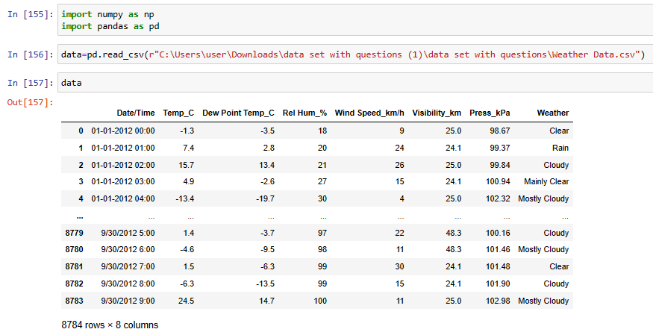

- 1) Find all the unique 'Wind Speed' values in the data.

- Code:
data["Wind Speed_km/h"].unique()

- Report:
From the given dataset To get the unique values in
“ Wind speed_km\h” we can use unique() function.Then it will Provide unique values of that column.

- Output:

array([ 9, 24, 26, 15, 4, 0, 19, 17, 11, 22, 35, 13, 20, 6, 7, 30, 32,
41, 39, 28, 44, 33, 37, 52, 46, 2, 50, 48, 57, 63, 43, 83, 70, 54],
dtype=int64)

Q.2) Find the number of times when the 'Weather is exactly Clear'.

- Code :
c=data.loc[data["Weather"]=="Clear”].count()
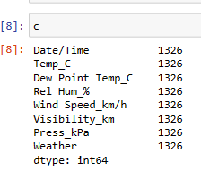

- Report : To count the number of occurrences where the weather is “clear” in the dataset,we can use following code:data.loc[data["Weather"]=="clear"].count()
This will give the count of occurences where the weather is clear.

- Output : 0

Q.3) Find the number of times when the 'Wind Speed was exactly 4 km/h'.

- Code :
data.loc[data["Wind Speed_km/h"]==4].count()

- Report : To count the number of occurences where the Wind speed is 4 km/h in the dataset,we can use the following code:
data.loc[data["Wind Speed_km/h"]==4].count()

- Output :Date /Time 474
Temp_C 474
Dew Point Temp_C 474
Rel Hum_% 474
Wind Speed_km/h 474
Visibility_km 474
Press_kPa 474
Weather condition 474
dtype: int64

- 4) Find out all the Null Values in the data.

- Code : data.isna().count()

- Report :To count the number of NaN values in each column of the dataset,we can use the code data.isna().count().This will give the count of NaN values in each column.

- Output : Date/Time 8784
Temp_C 8784
Dew Point Temp_C 8784
Rel Hum_% 8784
Wind Speed_km/h 8784
Visibility_km 8784
Press_kPa 8784
Weather condition 8784
dtype: int64

- 5) Rename the column name 'Weather' of the dataframe to 'Weather Condition'.

- Code :data.rename(columns={"Weather":"Weather condition"},inplace=True)

- Report : To Rename columns in a DataFrame,we can use the Rename()function.The above code renames the “Weather” column to “Weather condition” in the data.Here inplace=True parameter is used to modify the DataFrame directly.

- Output :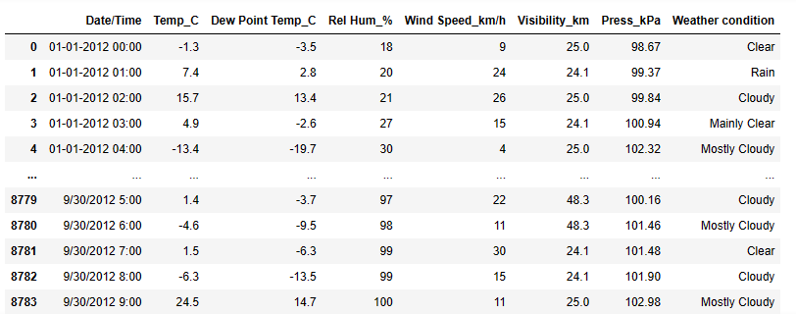

Q .6) What is the mean 'Visibility' ?

- Code :data["Visibility_km"].mean()

- Report :From the above code we can find the mean for the column “visibility”.It will give the mean vale of the required column.

- Output : 27.6644467213114

- 7) What is the Standard Deviation of 'Pressure' in this data?

- Code :data["Press_kPa"].std()

- Report :To find the standard deviation we use above code.It will give the standard deviation of the pressure values in kilopascals.

- Output : 0.8440047459486459

Q.8) What is the Variance of 'Relative Humidity' in this data ?

- Code :data["Rel Hum_%"].var()

- Report : To find the variance for the data in the column name “Relative Humidity” we use above code.It will give the variance for the column name “Relative Humidity” is 286.24

- Output : 286.2485501985015

Q.9) Find all instances when 'Snow' was recorded.

- Code :data.loc[data["Weather condition"]=="Snow"]

- Report :We use above code to know the data whose weather condition is “snow”.Here the data gives the DataFrame table where the data consist of weather condition as snow.

- Output :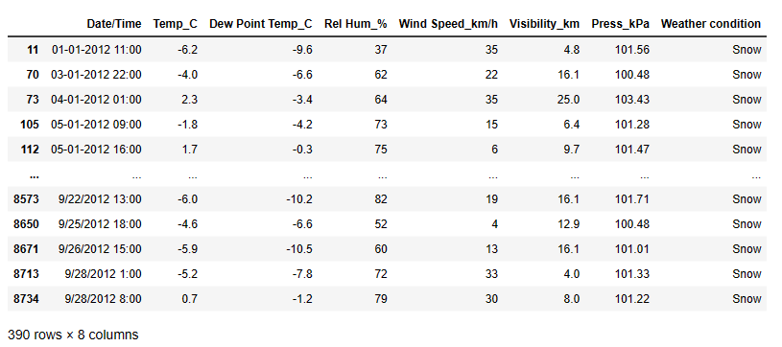

Q.10) Find all instances when 'Wind Speed is above 24' and 'Visibility is 25'.

- Code : data.loc[(data["Wind Speed_km/h"]==24)&(data["Visibility_km"]==25)]

- Report :

- To know the data whose wind speed is greater than 24 and visibility is equal to 25 we use above code.

- It gives the data of colum name”wind speed greater than 24 and also should satisfy the condition for the column name “visibility” is equal to 25.

- We got 308 data point which satisfies both the conditions.

- Output :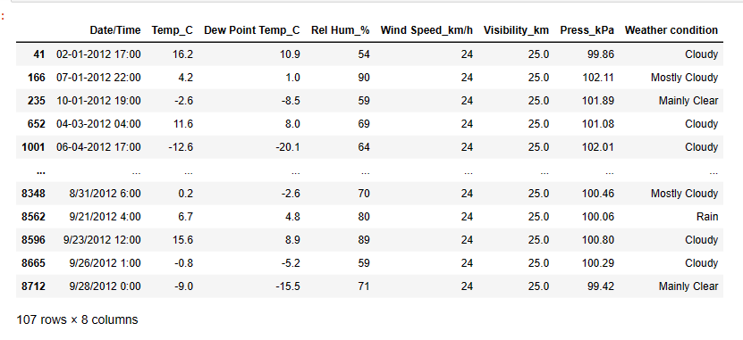

Q.11) What is the Mean value of each column against each 'Weather Condition ?

- Code : g=data.groupby("Weather condition")

- Report :
- To find the column “weather condition” by using groupby() function.groupby() will specify the data into different categories in the particular column.

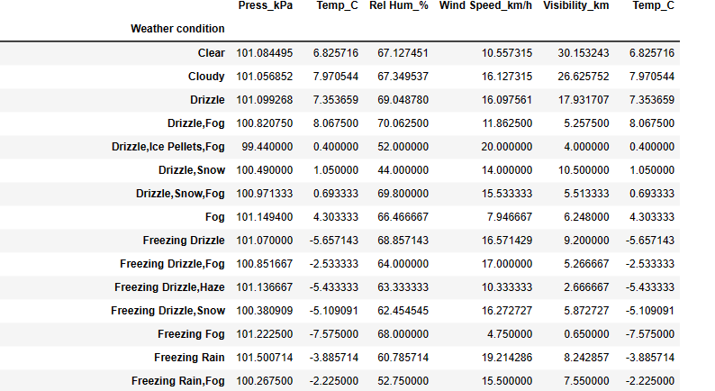

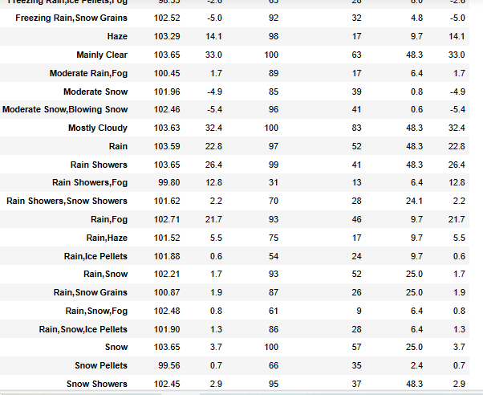
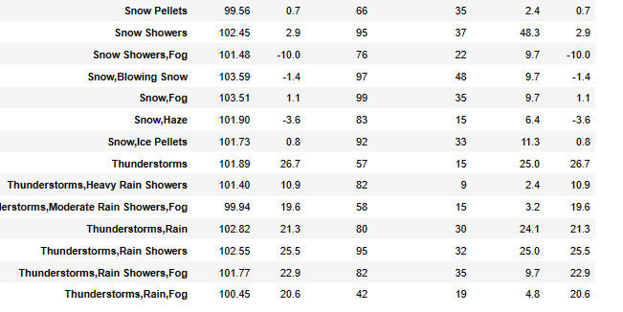

Q.12) What is the Minimum & Maximum value of each column against each 'Weather Condition ?

- Code : g[["Press_kPa","Temp_C","Rel Hum_%","Wind Speed_km/h","Visibility_km","Temp_C",]].min()
- g[["Press_kPa","Temp_C","Rel Hum_%","Wind Speed_km/h","Visibility_km","Temp_C",]].max()

- Report :To know the minimum and maximum data for the column on the specified column we use above code.It will give the minimum and maximum values of pressure,temperature,relative humidity for each weather condition in data.

- Output :

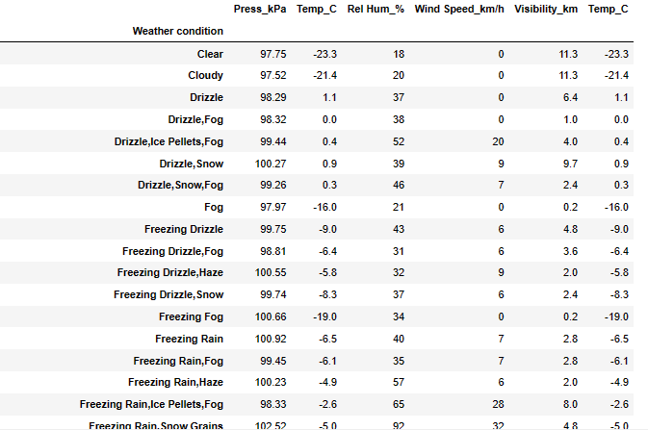

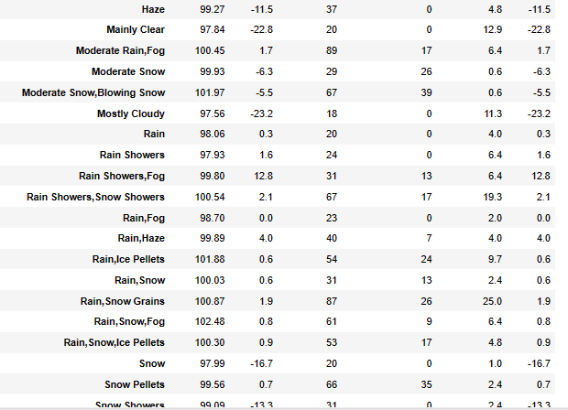

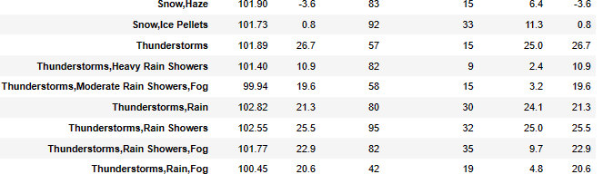

Q.13) Show all the Records where Weather Condition is Fog.

- Code : data.loc[data["Weather condition"]=="Fog"]

- Report :To know the data records whose weather condition is Fog we use above code.It gives the entire data for the weather condition is equal to fog.
- Output :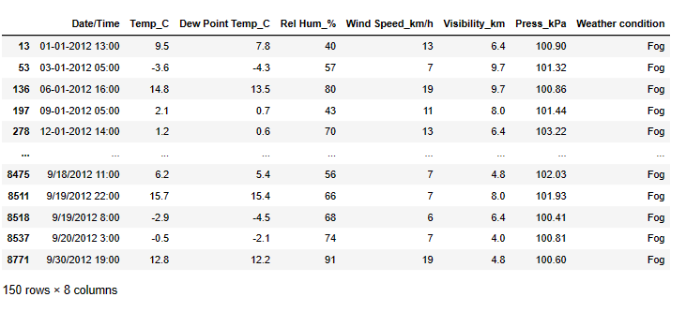
Q.14) Find all instances when 'Weather is Clear' or 'Visibility is above 40'.

- Code : data.loc[(data["Weather condition"]=="clear")|(data["Visibility_km"]>40)]

- Report :To get the data for the condition is clear or visibility is above 40 we use above code from that we get the data which satisfies the condition that weather condition is clear or visibility is greater than 40.In the above code we use bitwise or(|)operator to satisfy the condition.

- Output :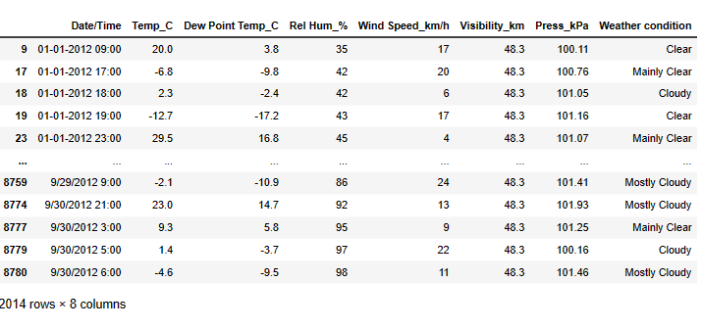
Q. 15) Find all instances when :
A. 'Weather is Clear' and 'Relative Humidity is greater than 50'
or
- 'Visibility is above 40'

- Code : data.loc[((data["Weather condition"]=="clear")&(data["Rel Hum_%"]>50))|(data["Visibility_km"]>40)]

- Report :To get the data for the conditions either weather condition is clear and Relative humidity is greater than 50 or else the visibility is greater than 40.

- In the condition we should use the bitwise or (|)operator to satisfy the conditions.

- Output :

- 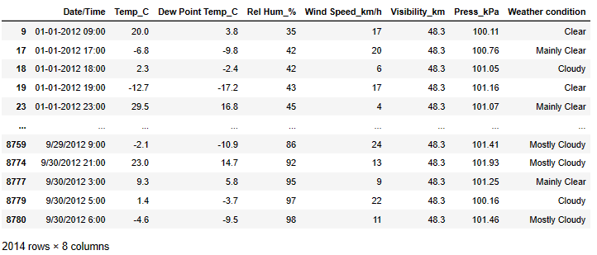

- And the above data satisfied the conditions.

- We have the total count of 2864 datapoints from the data which satisfies the conditions for the weather condition should be clear and relative humidity greater than 50 or else the visibility is greater than 40.

